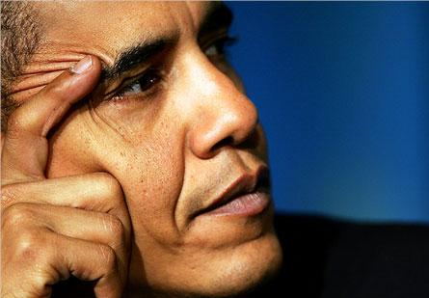

OBAMA

Obama is a big change, not only for the United States of America, but for the whole World. This black president assumes the heavy task of governing a country in crisis by reaffirming a greatness that must be earned, renewing its agreement to human rights, and offering friendship to the world.

Obama begins an era of responsibility, saying that a country cannot prosper if it favours only the more prosperous. All power falls on him as the president of the most powerful country in the world.

Thousands of colour people, including Kenyans, overcome with excitement and pride, watched his black brother’s inauguration ceremony, Barack Obama, the 44th President of the United States.

All his supporters were looking forward to the day on which he achieved the summit of power, sitting on the most powerful chair of the planet.

Some people voted for him because he was black and because his election would be the culmination of the long march on Washington, which started two years after Obama’s birth, carried out by the “dreamer” Martin Luther King.

Others voted against him because he was black and, despite his incomparable cultural revolution, racism still persists in the United States.

I finish with the words with which everybody will remember the first black president’s address: “honesty and hard work, courage and fair play, loyalty and patriotism”

Cayetana Donoso Blanco
cdonoso@e-quercus.es
ESO 4

