SUMMARY OF THE MEETING IN Büyükçekmece - turkey

FROM 13TH TO 19TH OF FEBRUARY 2011.

Sunday, 13th of February.

Arrival at the airport of Istanbul. Transport from the the airport to Büyükçekmece. Arrival at ‘Emlak Konut Mimarsinan Anadolu Lisesi’ and meeting with the students’ families. Accommodation at the Artemis Marin Princess Hotel in Kumburgaz, Istanbul.

Monday, 14th of February

09:00 Welcome at school and greetings by the School Director.

After the welcoming, the coordinator of the partnership presented the evaluation of the 1st year of the project commenting the results of a survey that had been previously answered by the coordinators in each school. As a consequence of the analysis of the results, all the participants agreed that the communication among the students should be improved. In order to get this aim, a new list of the email addresses of the students involved in the project will be done and sent to the coordinators in each school. Coordinators and teachers involved in the project will encourage and facilitate the communication among the students. Videoconferences and social networks, like facebook, could be used to motivate the students to get in touch.

Presentation of the activities done by the Turkish school ‘EMLAK KONUT MIMARSINAN LISESI’

Mr. Harum Reşit Ünüvar, after presenting the recent History of Turkey, showing its transformation in a modern country, explained the Turkish Educational system. This presentation was supported by several videos that helped to understand the changes operated in the country from 1922 until the present time. After lunch, the other schools started to present and evaluate the work done since the last meeting in Badia Polesine, Italy.

The Spanish school IESO QUERCUS, presented the new Teaching Units prepared about the universal values of tolerance, friendship, labour, freedom and justice, and also presented the logos created to publicise the project in the local community during the open days at school.

The Greek school GYMNASIO EFKARPIAS, informed about the celebration of the open day at school: information about the countries taking part in the project, presentation of pictures, leaflets …
It was also presented the Teenager Books Exhibition that was prepared in the school. During the exhibition, books from different countries were shown in order to reflect on the likes and topics of European teenagers readings. Finally, a new teaching unit about ‘friendship’ was presented, and also was shown the way this lesson was developed with the students: brainstorms, short essays (e.g ‘talking to my friend’) drawing a tree of friendship…

The Bulgarian school SREDNO OBSHTOOBRAZOVATELNO UCHILISHTE IVAN VAZOV presented some folk tales, popular in the countries of the partnership, the students have read. The reading of the tales was preceded by an explanation to place the tales in context. The presentation about the use of caricatures to communicate values was very original, and the video ‘Young Comments about Turkey’ was as nice as usual.

The Romanian school COLEGIUL NATIONAL PEDAGOGIC CONSTANTIN BRATESCU presented a new teaching unit about ‘Equal rights in spiritual path in intercultural Dobrudga’. The unit was part of ‘the week of diversity’, an activity done in the school on the topic ‘different but equals’ that reflects on groups with difficult ethnic backgrounds. The contribution of the Romanian school ended with a video about the town of Constanta.

Tuesday, 15th of February

09:00 Meeting at school.

1. Before going on with the presentation of the work done, the coordinator of the project encouraged the participating teachers to improve the communication among the students of the involved schools. These were the agreements in order to improve the communication among the students:
- To update the email list of the students involved in the project in each school.
- To organize videoconferences among the schools.
- To encourage the students to get in touch with each other regularly, especially to celebrate seasonal festivals and holidays.
- To promote students’ exchange among the schools.
- To generalize the programme of mobility of students some schools are currently developing.

The coordinator of the partnership encouraged the participants to prepare and write contributions, both in the national language and in English, for the school magazine of the project to be publicised in June. It was also reminded to prepare digital files of no more than 20Mb to facilitate the uploading of the activities, materials and products on the website and also the future recording on DVD's. Before going on with the presentation of the work done, teachers visited the host school and could meet the students during some lessons, especially during the workshops they were carrying out.

2. Presentation of a video about Istanbul by Mrs. Öznur Ünçok, teacher of English. This video helped us to know the history of the town and also to prepare the cultural visit to Istanbul.

3. Presentation of a digital activity about ‘LOVE’, preceded of a lovely explanation by Mrs. Sevim Kinali, teacher at the Turkish school.

4. The Dutch school RSG SLINGERBOS/LEVANT presented an experience about how to work on universal values through drama. Mrs. Irene showed a student performance representing, e.g. peace and its opposite, friendship versus hostility…

We were surprised making a stop in the presentations programme to plant trees, one per school, in the garden of the host school. According to the School Director wish, these trees will keep permanent memories of the collaboration and friendship among the eight schools from all over Europe taking part in this meeting. All the participants wish that the growth of these trees are going to symbolize the cooperation among the schools taking part in the partnership in the future.

5. Mrs. Emanuela from the Italian school ISTITUTO DI ISTRUZIONE LICEO SCIENTIFICO E. BALZAN, revived the last meeting showing a video about the workshops and other activities carried out in Badia Polesine, including the visit to the city of Florencia, both teachers and students.

6. Mrs Anneli and Mrs Heljia teachers of the Finnish school KAITAAN LUKIO, presented the activities done by their students about universal values. They encouraged to visit the renewed school website www.kaitaanlukio.fi, where many other activities can be browsed.

Finally, the work to be done until the next meeting in Sopot, Bulgaria, was commented. It was also reminded the dates for the meeting: from Wednesday, April 27th (arrival) to Monday, May 2nd (departure).

The delicious traditional Turkish dinner, prepared at school by the families, was the perfect note on which to finish a day full of nice and fruitful experiences and productive work.

Wednesdayy, 16th of February

Cultural trip to visit Sultan Ahmet aerea.

08:30 The bus picked up students and teachers. We visited Sultanahmet Mosque (better known as the ‘Blue Mosque’), the Islamic Art Museum, Hagia Sofia, Basilica Cistern, Topkapi Palace and Grand Bazaar. Our teachers guides were Mrs. Safiye and Mrs. Öznur. Thanks a lot for showing us these awesome places and monuments.
The domes and six minarets of the Blue Mosque dominate the skyline of Istanbul. In the 17th century, Sultan Ahmet I wished to build an Islamic place of worship that would be even better than the Hagia Sophia, and the mosque named for him is the result. The two great architectural achievements now stand next to each other in Istanbul's main square, and it is up to visitors to decide which is more impressive.

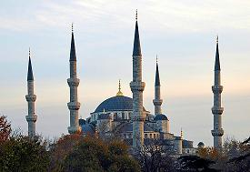

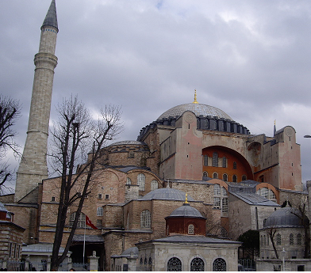
The Church of the Holy Wisdom, known as Hagia Sophia (Άγια Σοφία) in Greek, Sancta Sophia in Latin, and Ayasofya in Turkish, is a former Byzantine church and former Ottoman mosque in Istanbul. Now a museum, Hagia Sophia is universally acknowledged as one of the great buildings of the world. Hagia Sophia was rebuilt in her present form between 532 and 537 under the personal supervision of Emperor Justinian I.

Thursday, 17th of February
Cultural trip to Büyükada

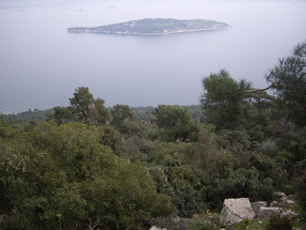

Early in the morning we took the ferry to visit Büyükada, Big Island in English. This is the largest of the nine islands comprising the Princes’ Islands in the Marmara Sea, close to Istanbul. We walked up a steepy path to reach the top of the mountain where Ayia Yorgi Church and Monastery (dating back 6th century) are built.

It was worth the climb to enjoy the beautiful views of the Marmara Sea from the highest point of the island. In the evening, after strolling Istiklal Street, we visited Galata Tower, the best place to view the city of Istanbul from its four corners. Thanks to Mrs. Safiye and Mrs. Ayten’s kindness we all spent a very nice day.

Friday, 18th of February.

At 8:00 in the morning we were on the bus toward Istanbul. Before the scheduled Bosphorus tour we visited Dolmabahçe Palace. It was a guided visit and the guide’s explanations helped us to understand better the parts of the palace we visited and the things we were seen in it. It was a sunny and quite warm day, the ideal weather to enjoy the Bosphorus tour. We had lunch on the boat and even fed the seagulls following the ship. The views of Istanbul from the sea are stunningly beautiful, especially the magnificence of Dolmabhçe Palace.
Dolmabahçe Palace was ordered to be built by the Empire's 31st Sultan, Abdülmecid I, and built between the years 1843 and 1856. Dolmabahçe Palace (Dolmabahçe Saray in Turkish) is located on the European side of the Bosphorus, and served as the main administrative centre of the Ottoman Empire from 1856 to 1922.

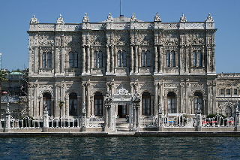

After the Bosphorus tour we visited the Army Museum with the seeing of Mehter Athem.

At 19:30 in the evening was the students’ performance at school. Before the show prepared by the students, the School Director, the Education Councelor and the Coordinator of the Proyect ‘Beyond Words’ emphasize the importance of Education and experiences like this to promote friendship, universal values and Europe. In this Comenius Proyect schools from all over Europe, which differ in their educational profiles, share experiences to face the same educational problems. The students’ performance

was very emotive and well prepared. Congratulations to the students and teachers involved in the show because this moment will be unforgetable.

The subsequent dinner for teachers, with so delicious typical food and music until late at night, was the perfect atmosphere to say not ‘goodbye’, but ‘see you soon, friends!

