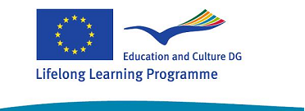

PROPOSAL OF WORK

From 15th of September to 15th of October:

DATA EXCHANGE AND ACTIVITIES TO KNOW EACH OTHER.

- Email-contact among the pupils from the participating countries to get to know each other

Each school must send a list with the email addresses of the pupils involved in the project to the other schools so that the pupils could exchange messages.
If they have ‘messenger’ they could also chat among them.
The idea is that the students of every school exchange messages with all the other schools.

- To produce digital files, for instance a PowerPoint or some PowerPoints to show to the other countries the own school, the town, the surrounded area…

These presentations can be made by students and teachers. When they are finished, send the files by the Internet to the other countries.

- To produce a DVD compiling these presentations in English for all partners.

This DVD could be use in the presentation of each school during the project meeting. Looking at each others’ DVDs will help to know each other.
In the first project meeting every school should give a copy of its own DVD to the other schools.
Later I will find the way of producing a larger DVD with all the presentations, and this DVD will be one of the final products of the partnership.

From 16th to the 31st of October

- To design and print a brochure to publicize the project.

Every school should design a brochure to give publicity of the project in the school, in the local community…

A copy of the brochure will be give to the other schools in the first meeting.

