SUMMARY OF THE MEETING IN BADIA POLESINE

FROM 27th SEPTEMBER TO 2nd OCTOBER 2010.

Monday, 27th September.

Arrival at the airport of Venice.

At 18:30 transport from the airport to Badia Polesine. Arrival at Liceo Scientifico “Balzan” and meeting with the students´ families. Everybody was happy to meet all the Comenius participants again.

Dinner and accommodation at the hotel “Le Magnolia”.

Tuesday, 28th September.

8:00 Welcome meeting at school and greeting by the Headmaster. General information about the project meeting.

Visit of the school.

9:00 Presentation and evaluation of the work performed by each school during the first year of the project.

Presentation of didactic units using videos and PowerPoint.

1) Presentation of the KAITAA SENIOR SECONDARY SCHOOL, FINLAND:

- Photos of the new school building with beautiful pictures.
- Beyond words, idea of the tasks for Finnish students.
- Finnish lifestyle.

2) Presentation of didactic units of the Turkish school, showing the following topics:
- A beautiful Power Point showing the life of Nelson Mandela.
- Wonderful pictures showing the richness and antiquity of Istanbul.
- School projects made by students related to all the participant countries, using pictures, flags…
3) Presentation by the Italian school of a teaching unit on Rationality.
The teaching unit contains a good number of comments and materials and almost all the geometric images can be opened and manipulated by means of the software they were created with.

After that, the evaluation of the first year of Comenius was seen by the participants.

Lunch at school

15:00 Discussing about the tasks of the second year.

Presentation of some aspects of Florence

Wednesday, 29th September

A day trip to Florence, we saw Palazzo Pitti, la Loggia del Borromini, S. Maria in fiori and Ponte Vecchio.

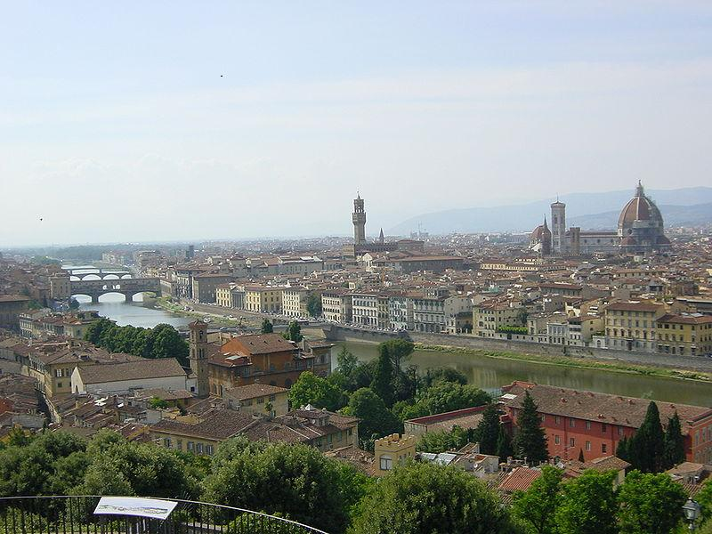
Beautiful view from Piazza Michelangelo

Florence is a city located in the North of the central Region of Italy. It is the main economic, artistic, historical site in Toscana. It has got about 368.901 inhabitants and it’s the city centre of a metropolitan area of a million and a half inhabitants. It became an important cultural, flourish and financial site in medieval times with the Dinastia Medici. It was also the capital of Italy from 1865 to 1871 while the Italian Union was taking place. Florence is considered as the birth of the Art and Architecture, since it’s the place where the Renaissance was born. In 1982 it was declared as a WORLD HERITAGE CITY.

19:30 Return to Badia Polesine.

20:00 Dinner

Thursday, 30th September

8:00 Meeting at school in the Assembly Hall.

Walk to the city centre. We had a warm welcome by the major of Badia at the town hall. Students were given a key ring and each school was given a lovely picture of Badia. After that, there was a ‘Mandala workshop’ in the city centre, it consisted of drawing things using colour chalk mixed with rice.

Later, we were shown the Abbazia della Vangadizza, which belongs to the 10th century, a wonderful theatre which is being rebuilt now and a beautiful painting about “The last dinner”.

Friday, 1st October

Work at school. There was a discussion about the activities to prepare the “Open Day” that will be celebrated in each school on the 2nd of November.

12.30 Departure for Ferrara and lunch there.

Ferrara is ancient and lovely city of about 134.967 inhabitants 2009). It is located on the Po de Volano river. The city has got an urban distribution from XIV century, when it was ruled by the ESTE family. The medieval design was projected by Biago Rosseti and it became the first modern city in Europe, that's why it was considered WORLD HERITAGE CITY in 1995.
Visit of the ancient town: il Castello, il Duomo, le mura, S. Romano e vie delle Volte.

19:00 Return to Badia Polesine.
20:00 Dinner at a pizzeria.

Saturday 2nd October,

Departure

