BEYOND WORDS

THE COMMUNICATION OF UNIVERSAL VALUES
THROUGH
THE LANGUAGE OF ART

TEACHING UNIT 3

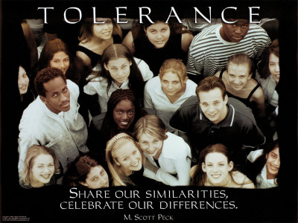

Tolerance is a fair, objective, and permissive attitude toward those whose beliefs or personal characteristics (race, religion, nationality, etc.), differ from one's own.
(From Wikipedia, the free encyclopedia)



Толерантност Toleranssi Ανοχής Tolleranza Tolerantie Toleranţă Tolerancia Hoşgörü

THE COMMUNICATION OF UNIVERSAL VALUES THROUGH PAINTING

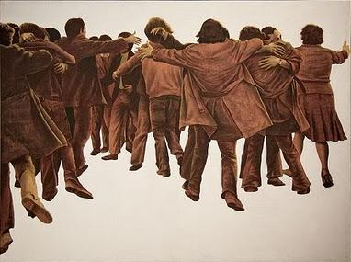

THE COMMUNICATION OF UNIVERSAL VALUES THROUGH THE SCULPTURE

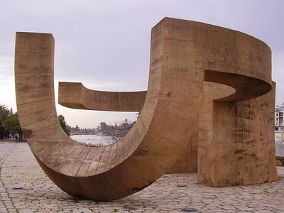

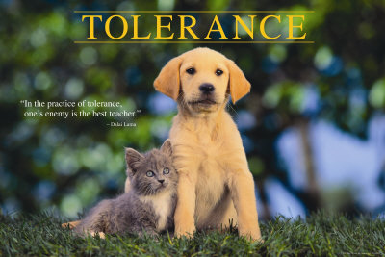

The embrace
El abrazo

The embrace is a canvas by Juán Genovés painted in 1976. It is located in the Reina Sofia Museum in Madrid. It was used as a symbol of the Spanish transition to democracy, the era when Spain moved from the dictatorship of Francisco Franco to a democratic state.

To be stablished the Spanish democracy was necessary a big dose of tolerance among the political parties, and also among citizens with different ways of thinking.

Monument to tolerance
Monumento a la tolerancia

The monument to tolerance by Eduardo Chillida was inaugurated in April 1992 to coincide with the 500th anniversary of the decree signed by the Catholic Monarchs, by which the Jews were expelled from the Spanish territory.

The monument also reminds the murder of five members of a Jewish family during the expulsion of 1492.
It is located in Seville, a town in Andalusia, in the south of Spain.

THE COMMUNICATION OF UNIVERSAL VALUES THROUGH THE MUSIC

‘CONTAMÍNAME’ is a song about the topic of immigration and intercultural relationships.

CONTAMÍNAME

Cuéntame el cuento del árbol dátil de los desiertos;
de las mezquitas de tus abuelos.
Dame los ritmos de las darbucas y los secretos,
que hay en los libros que yo no leo.

(Estribillo)

Contamíname, pero no con el humo que asfixia el aire,
ven, pero si con tus ojos y con tus bailes.
Ven, pero no con la rabia y los malos sueños,
Pero si con los labios que anuncian besos.

Contamíname, mézclate conmigo,
que bajo mi rama tendrás amigo.
Contamíname, mézclate conmigo,
que bajo mi rama tendrás amigo.

Cuéntame el cuento de las cadenas que te trajeron;
de los tratados y los viajeros.
Dame los ritmos de los tambores y los voceros,
del barrio antiguo y del barrio nuevo.

(Estribillo)

Cuéntame el cuento de los que nunca se descubrieron;
del río verde y de los boleros.
Dame los ritmos de los busuquis,
los ojos negros,
de la danza inquieta del hechicero.

(Estribillo)

Letra de Pedro Guerra

Ana Belén - Contamíname.

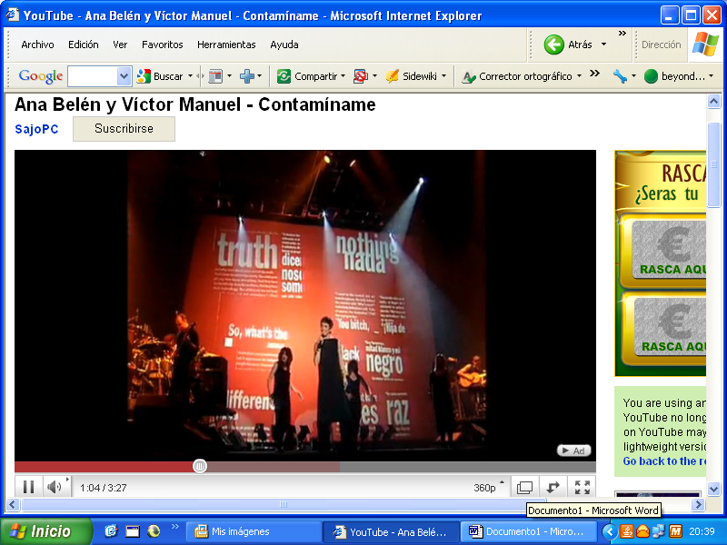

http://www.youtube.com/watch?v=zvtyugdol14

Click on the links to watch the video performed by Ana Belén and Víctor Manuel

CONTAMINATE ME

Tell me the story of the date tree of the deserts;
the mosques of your grandparents.
Give me the rhythms of the darbucas and secrets
which can be found in the books that I don’t read.
(Chorus)
Contaminate me, but not with the smoke polluting the air,
but with your eyes and your dancing.
Come, but not with anger and bad dreams,
But with the lips that announce kisses.
Contaminate me, mix with me
under my tree you will have shelter
Contaminate me, mix with me
under my tree you will have shelter
Tell me the story of the chains that brought you;
of treaties and travellers.
Give me the rhythm of drums and spokesmen,
of the old neighbourhood and also of the new one.
(Chorus)
Tell me the story of those who were never discovered;
of the green river and boleros.
Give me the rhythms of the busuquis,
the black eyes,
of the restless dance of the socerer.

(Chorus)

Lyrics by Pedro Guerra

Pedro Guerra - Contamíname

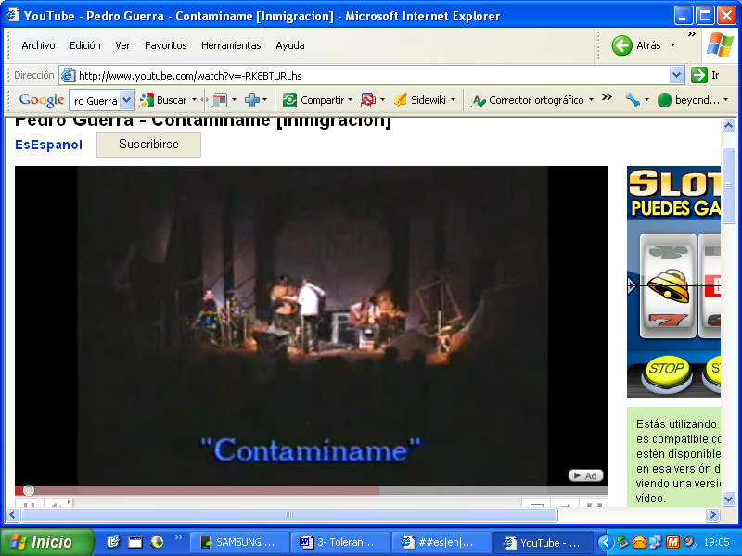

http://www.youtube.com/watch?v=-RK8BTURLhs

Click on the links to watch the video performed by Pedro Guerra

‘LA MURALLA’ is a song about the topic of tolerance and brotherhood among all human beings.

LA MURALLA

Para hacer esta muralla,
tráiganme todas las manos
los negros, sus manos negras
los blancos, sus blancas manos.
Una muralla que vaya
desde la playa hasta el monte
desde el monte hasta la playa,
allá sobre el horizonte.
—¡Tun, tun!
—¿Quién es?
—Una rosa y un clavel...
—¡Abre la muralla!
—¡Tun, tun!
—¿Quién es?
—El sable del coronel...
—¡Cierra la muralla!
—¡Tun, tun!
—¿Quién es?
—La paloma y el laurel...
—¡Abre la muralla!
—¡Tun, tun!
—¿Quién es?
—El gusano y el ciempiés...
—¡Cierra la muralla! (Estribillo)
Al corazón del amigo:
abre la muralla;
al veneno y al puñal:
cierra la muralla;
al mirto y la hierbabuena:
abre la muralla;
al diente de la serpiente:
cierra la muralla;
al corazón del amigo:
abre la muralla;
al ruiseñor en la flor…
Alcemos esta muralla
juntando todas las manos;
los negros, sus manos negras
los blancos, sus blancas manos.
Una muralla que vaya
desde la playa hasta el monte
desde el monte hasta la playa,
allá sobre el horizonte. (Estribillo)
ANA BELÉN & VÍCTOR MANUEL - LA MURALLA

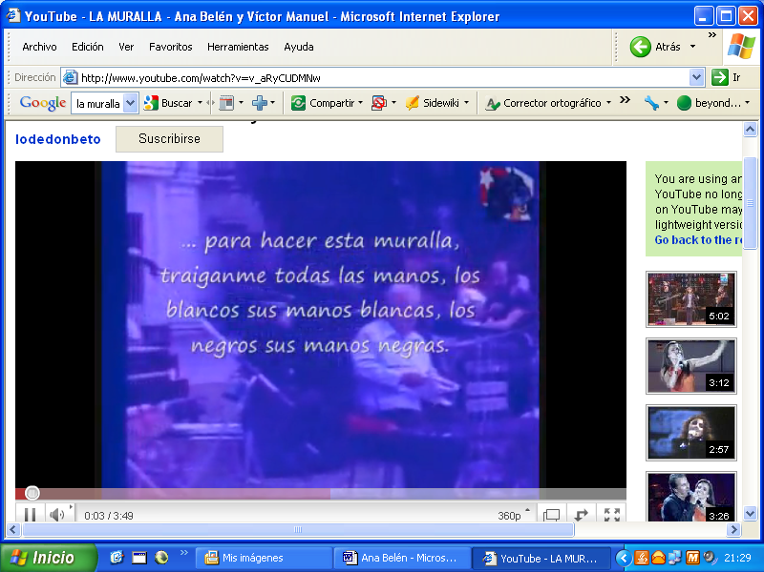
CLICK ON THE LINKS TO WATCH THE VIDEOS.

http://www.youtube.com/watch?v=v_aRyCUDMNw

THE WALL

To build this wall,
bring me all hands
blacks, black hands
whites, their white hands.
A wall that will go
from the ocean to the mountain
from the mountain to the beach
beyond the horizon.
- Tun, tun!
- Who is it?
"A rose and a carnation ...
- Open the wall!
- Tun, tun!
- Who is it?
"The sword of Colonel ...
- Close the wall!
- Tun, tun!
- Who is it?
"The dove and the bay ...
- Open the wall!
- Tun, tun!
- Who is it?
"The worm and the centipede ...
- Close the wall! (Chorus)
To the heart of your friend:
Open the wall;
to the poison and the dagger:
Close the wall;
to myrtle and mint:
Open the wall;
to the serpent's tooth:
Close the wall;
to the heart of your friend:
Open the wall;
to the nightingale on the flower ...
We raise this wall
joining all hands;
blacks, black hands
Whites, their white hands.
A wall that will go
from the ocean to the mountain
from the mountain to the beach
beyond the horizon beyond. (Chorus)

QUILAPAYÚN & ANA BELÉN - THE WALL

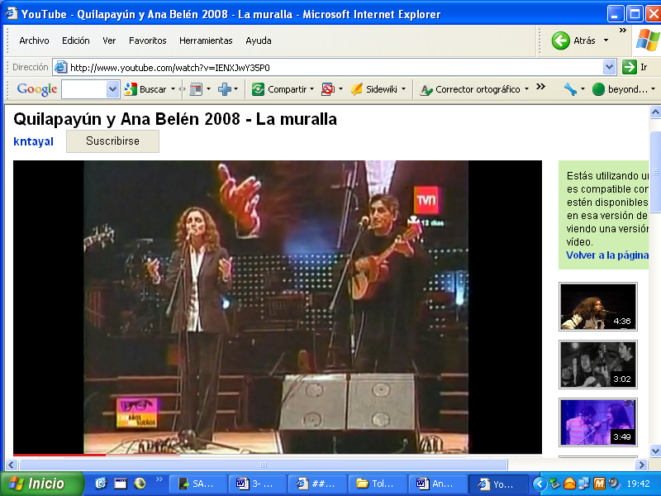

http://www.youtube.com/watch?v=IENXJwY35P0

ACTIVITY 1:

1.- Can you give your own explanation of what Tolerance is?

…………………………………………………………………………………………………………………………………………………………………………………………………………………………………………………………………………………………………………………………………………………………………………………………………………………………………………

2.- Why do you think this poster has been chosen to promote Tolerance?

…………………………………………………………………………………………………………………………………………………………………………………………………………………………………………………………………………………………………………………………………………………………………………………………………………………………………………

3.- What do you think people are looking at?

…………………………………………………………………………………………………………………………………………………………………………………………………………………………………………………………………………………………………………………………………………………………………………………………………………………………………………

4.- Could you write your own sentence about tolerance for the poster ?

……………………………………………………………………………………………………………………………………………………………………………………………………………………

ACTIVITY 2

1.- Why do you think this poster has been chosen to promote Tolerance?

……………………………………………………………………………………………………………………………………………………………………………………………………………………………………………………………………………………………………………………………………………………………………………………………………………………………………………………………………………………………………………………………………………………

2.- In your opinion, which is the meaning of this image?

…………………………………………………………………………………………………………………………………………………………………………………………………………………………………………………………………………………………………………………………………………………………………………………………………………………………………………

3.- Cats and dogs being different can live together. Do you know any other kind of animal
that could be used to express the idea of Tolerance?

…………………………………………………………………………………………………………………………………………………………………………………………………………………………………………………………………………………………………………………………………………………………………………………………………………………………………………

4.- Could you write a sentence for the image of the cat and the dog being happy together?

…………………………………………………………………………………………………………………………………………………………………………………………………………………………………………………………………………………………………………………………………………………………………………………………………………………………………………

