BEYOND WORDS

THE COMMUNICATION OF UNIVERSAL VALUES
THROUGH
THE LANGUAGE OF ART

TEACHING UNIT 7

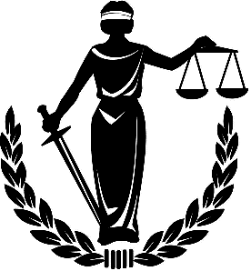

Justice is the concept of moral rightness based on ethics, rationality, law, natural law, religion, fairness, or equity, along with the punishment of the breach of said ethics.

(From Wikipedia, the free encyclopedia)

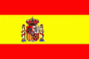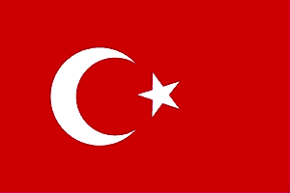

правосъдие еoikeuden δικαιοσύνης giustizia justitie justiţie justicia adalet
mukaisuus

THE COMMUNICATION OF UNIVERSAL VALUES THROUGH PAINTING

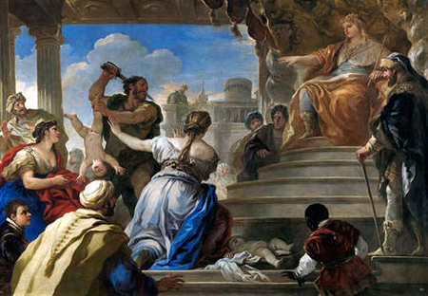

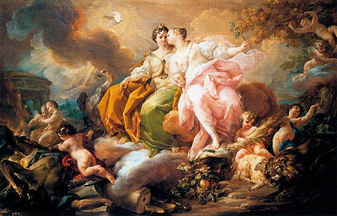

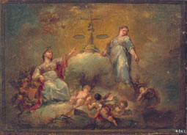

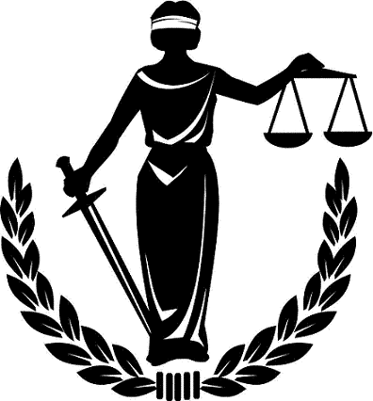

THE JUDGEMENT OF KING SALOMON
EL JUICIO DE SALOMÓN

Luca Giordano (1634-1705)
Museo del Prado. Madrid

Two women came before Solomon to resolve a quarrel about which was the true mother of a baby. One mother had her baby die in the night after rolling over it in her sleep and crushing it; each claims the surviving child as her own. When Solomon suggests dividing the living child in two with a sword, the true mother is revealed to him because she is willing to give up her child to the lying woman. Solomon then declares the woman who shows compassion to be the true mother, and gives the baby back to her.

PEACE AND JUSTICE
PAZ Y JUSTICIA

1755. Corrado Giaquinto
Museo del Prado. Madrid

The two allegorical figures represent Peace and Justice defeating War (in the bottom left). Peace has an olive branch, symbol of peace, and a cornupia full of fruits, symbol of wealth in times of peace.
Justice is depictied crowned and taking the baton in his hand and with the balance on her feet.

ALLEGORY OF JUSTICE

ALEGORÍA DE LA JUSTICIA

1835. Vicente Castelló y Amat
Valencia. Private collection

The scales, symbol of Justice, appear on a pedestad of clouds with two female figures on the sides and angels

Lady Justice

Justice is depicted as a lady equipped with three symbols: a sword symbolizing the court's coercive power; a human scale weighing competing claims in each hand; and a blindfold indicating impartiality.

THE COMMUNICATION OF UNIVERSAL VALUES THROUGH SCULPTURE

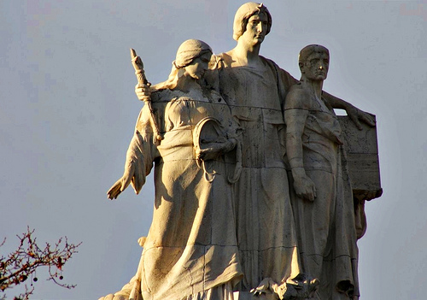

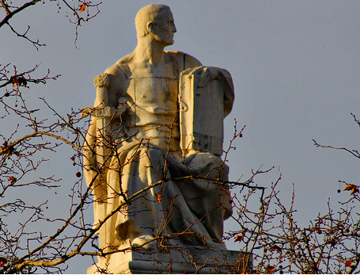

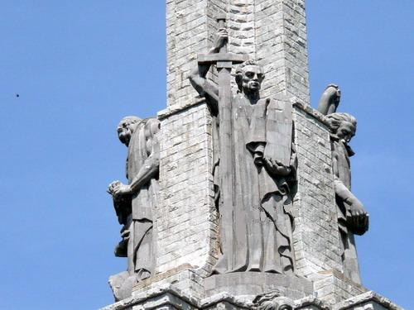

Allegory of Justice
Alegoría de la Justicia

Supreme Court of Spain
Plaza de la villa de Paris. Madrid

This allegory represents Justice holding the baton and pointing the law code.

JUSTICE
LA JUSTICIA

Supreme Court of Spain
Plaza de la villa de Paris. Madrid

In this statute Justice is depicted by a man holding the sword and the code law.

MEMORIAL TO JUSTICE
MONUMENTO A LA JUSTICIA

1952. Juan de Ávalos Taborda
Valle de los caídos.
San Lorenzo de El Escorial. Madrid
In this memorial Justice is also represented by a man holding a sword with his right hand and the law code with the left hand.

ACTIVITY 1 - HOW TO BE A FAIR PERSON

List the following behaviours ‘Fairness Do’s’ or ‘Fairness Don’ts’

Treat people the way you want to be treated.
Take turns.
Tell the truth.
Play by the rules.
Think about how your actions will affect others.
Listen to people with an open mind.
Blame others for your mistakes.
Take advantage of other people.
Play favourites.
Treat all people fairly.
Take more than your fair share.
Listen to others and try to understand what they are feeling and saying.
Consider all the facts, including opposing views, before making a decision.
Take advantage of other people’s mistakes or ignorance.
Make impartial decisions, using the same criteria, rules, or standards for everyone.
Let personal preferences, prejudices or other feelings improperly interfere with decisions
which should be based on merit.

Fairness Do’s

…………………………………………………………………………………………………………………………………………………………………………………………………………………………………………………………………………………………………………………………………………………………………………………………………………………………………………………………………………………………………………………………………………………………………………………………………………………………………………………………………………………
……………………………………………………………………………………………………………………………………………………………………………………………………………………………………………………………………………………………………………………………………………………………………………………………………………………
……………………………………………………………………………………………………

Fairness Don’ts

…………………………………………………………………………………………………………………………………………………………………………………………………………………………………………………………………………………………………………………………………………………………………………………………………………………………………………………………………………………………………………………………………………………………………………………………………………………………………………………………………………………
……………………………………………………………………………………………………………………………………………………………………………………………………………………………………………………………………………………………………………………………………………………………………………………………………………………
……………………………………………………………………………………………………

ACTIVITY 2 - SELF- EVALUATION

Are You a Fair Person?
(Take this self-evaluation and decide for yourself.)

True | False
 |  | I treat other people the way I want to be treated.
 |  | I treat people with equanimity and impartiality.
 |  | I am open-minded and reasonable.
 |  | I play by the rules.
 |  | I don't take advantage of people.
 |  | I consider the feelings of all people who will be affected by my actions and decisions.
 |  | I consider all the facts, including opposing views, before making a decision.
 |  | I tell the truth
 |  | I don't blame others for my mistakes.
 |  | I don't play favourites.
I think I am/am not a fair person because: ___________________
"It is reasonable that every one who asks justice should do justice."
- Thomas Jefferson

ACTIVITY 3: JUSTICE WORDSEARCH
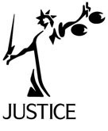

FIND THE WORDS BELOW IN THE WORDSEARCH

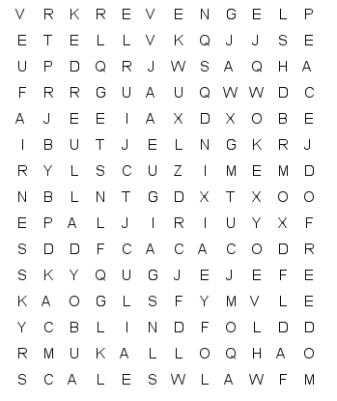

Words may be spelt
horinzontally , vertically and sidelong.

Circle each word as you find it.

FREEDOM EQUALITY LADY FAIRNESS

SCALES BLINDFOLD PREJUDICE PEACE

EQUALITY REVENGE SWORD JUDGE LAW

ACTIVITY 4: JUSTICE CROSSWORD
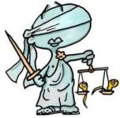

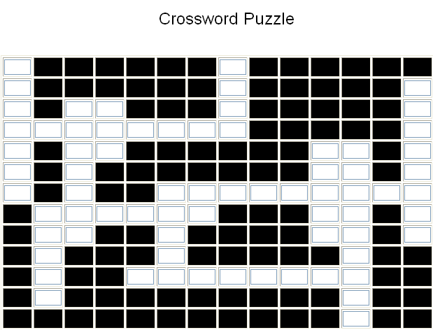
1
2
3
4
5
6
7
8
9
1
2
3
4

ACROSS
1. The principle under which each individual is subject to the same laws.
2. A baseless and usually negative attitude toward members of a group.
3. Representing and objective standard by which competing claims are weighed.
4. A harmful action against a person or group in response to a grievance.

DOWN
1. The right to behave according to one's own responsibility and free will.
2. Symbolizing the court's coercive power.
3. The concept of moral rightness.
4. A system of rules, usually enforced through a set of institutions.
5. Commonly understood as the absence of hostility.
6. A human figure to depict Justice.
7. Arbiter of justice who presides a court of law.
8. Symbol indicating impartiality.
9. Treating all people with honesty and respect.

WORDSEARCH SOLUTIONS

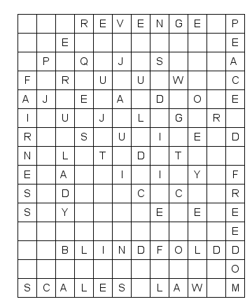

CROSSWORD SOLUTIONS

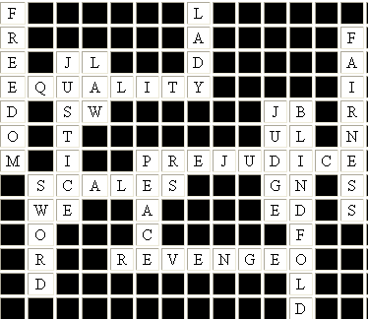

ACTIVITY 5: CONCEPT MAP OF JUSTICE AND FAIRNESS

Name ……………………………………………………………………………………………………………………………

After doing the previous activities, complete the following boxes.

Your definition of justice

……………………………………………………………………………………………………………………………………………………………………………………………………………………………………………………………………………………………………………………………………………………………………………………………………………………………………………………………………………………………………………………

Examples of justice in your world

……………………………………………………………………………………………………………………………………………………………………………………………………………………………………………………………………………………………………………………………………………………………………………………………………………………………………………
……………………………………………………………
……………………………………………………………

My point of view on justice

……………………………………………………………………………………………………………………………………………………………………………………………………………………………………………………………………………………………………………………………………………………………………………………………………………………………………………
……………………………………………………………
……………………………………………………………

Things I can do to promote justice

……………………………………………………………………………………………………………………………………………………………………………………………………………………………………………………………………………………………………………………………………………………………………………………………………………………………………………
……………………………………………………………
……………………………………………………………

Examples of injustice in your world

……………………………………………………………………………………………………………………………………………………………………………………………………………………………………………………………………………………………………………………………………………………………………………………………………………………………………………
……………………………………………………………
……………………………………………………………

My point of view on injustice

……………………………………………………………………………………………………………………………………………………………………………………………………………………………………………………………………………………………………………………………………………………………………………………………………………………………………………
……………………………………………………………
……………………………………………………………

Explain a symbol of justice

……………………………………………………………………………………………………………………………………………………………………………………………………………………………………………………………………………………………………………………………………………………………………………………………………………………………………………
……………………………………………………………
……………………………………………………………

