Jan Amos Comenius

A brief bio on the "Father" of modern education.

Some brief Notes on Jan Amos Comenius
By Dr. C. Matthew McMahon

Have you ever heard of Jan Amos Comenius? Do not be too overwhelmed with grief if you have not. In our day, most of the world has not heard of him. Regardless of your denominational distinction, Comenius is someone Christians should become familiar with. He wrote over 154 books in his lifetime, even after all of his original manuscripts were burned during a rebellion in Holland. He was an amazing and prolific educator, and has been stamped The Father of Modern Education. Born March 28, 15 92, orphaned early, educated at the universities of Herborn and Heidelberg, Comenius began working as a pastor and parochial school principal in 1618, the year the Thirty Years war began. After the defeat of the Protestant armies in the Battle of White Mountain one of the most disastrous events in Czech historyhe barely escaped with his life while enemy soldiers burned down his house. Later, his young wife and two small children died of the plague. For seven years he lived the life of a fugitive in his own land, hiding in deserted huts, in caves, even in hollow trees. Early in 1628 he joined one of the small groups of Protestants who fled their native Moravia to await better times in neighboring Poland. He never saw his homeland again.

For 42 years of his long and sorrowful life he roamed the countries of Europe as a homeless refugee. He was always poor. His second wife died, too, leaving him with four children to care for. The political allies of the Czech nation either died or were killed in the war. The beloved fatherland lay in total desolation. The scattered, impoverished church whose bishop he had become was in danger of disintegrating after years of exile. The Polish city of Leszno, his home for a number of years, was burned to the ground by the enemy. His treasured library and numerous manuscripts some of them results of decades of work were totally destroyed in the fire, leaving Comenius, an old man of 64, with virtually nothing but the clothes on his back. Homeless and penniless, he made it to Amsterdam, Holland, where friends took him in and cared for him until his death in 1670.

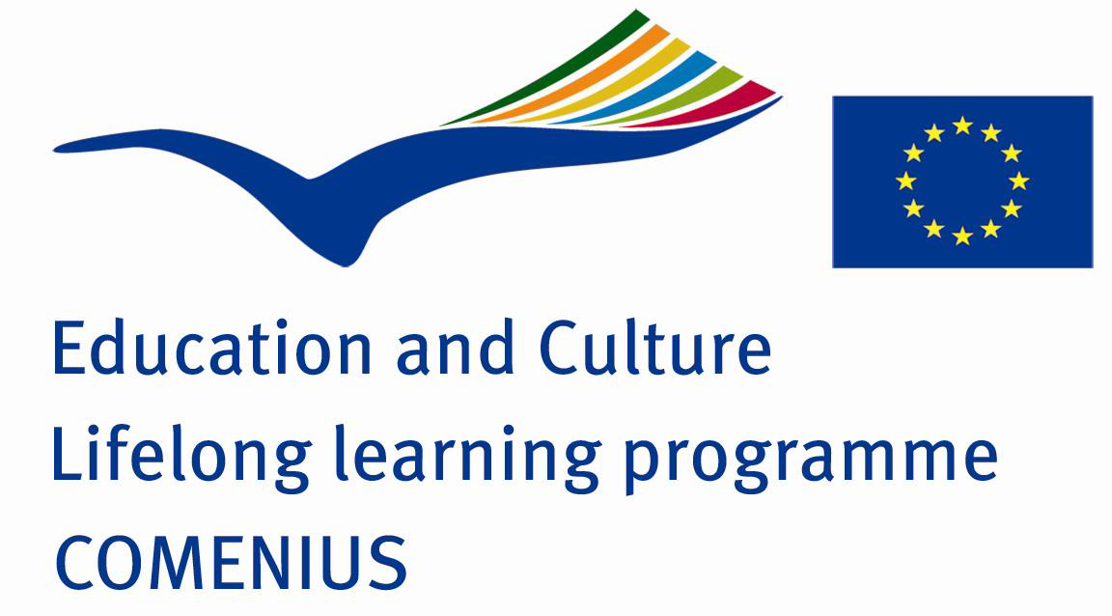
Comenius was a minister (an elder or bishop) of a church known as Unitas Fratrum (The Unity of Brethren), which attained great theological, literary and cultural achievements immediately preceding the Thirty Years War. While small in numbers, it spurred the whole Czech nation to great cultural advancement. The Brethren were exiled but saw themselves as guardians of Czech spiritual treasures. Hoping that one day they would return home, they were trying to prepare for the great task of rebuilding the land and the society devastated by war, and they knew that education would play a vital part in it. The Brethren did not believe they were the one true church without which you could not be saved, but part of the universal church in the world. No doubt there was much that influenced their thinking through Wickliffe missionaries to their country, and then later by Jan Hus in Bohemia. This Unity branch of Christians were heavily influenced by the Reformation started at the time of Hus (13691415). This Reformation did not die out in Bohemia when he was burned at the stake. A number of small communities spun off from the Hussites, each rebelling against Rome in their own ways. They said, Thus believing according to the Holy Writ in a Holy Church, we do not hold that we alone compose the Holy Catholic Church, or that salvation is obtained only among us, or that we alone shall be saved. Comenius was also not settled on the issue of predestination (he may have been more akin to an Amyraldian concept (a mix or rather confusion of issues in this way) but was very set upon bringing the church together an unifying her), or some of the controversies at the time on the Lords Supper between the Reformed church and the Lutherans.

Comenius wife and children died of the plague. Shortly thereafter his country was thrown into greater war and turmoil. The Unity of the Brethren was dying out, with Comenius as the most prominent figure of their church movement. In 1632 he became the bishop of his church. It was after the battle of White Mountain in Bohemia in 1620 and their banishment from the country that the church became all but extinct. He led a small group of people over the mountains into Poland in hopes that the hidden seed of faith that was ready to sprout would come forth. He found refuge for a short while there. He remarried, but his second wife also died leaving him with four children, and he married again, his third wife outliving him. His life was characterized by constant moving, despair and turmoil (this was part of the reason his second wife became ill and died). However, he composed many works on education and became famous all through Europe through his writings. He published some of the first picture books for children, as well as writing a work around pansophic principles that gained him wide renown. What does pansophic actually refer to? Comenius believed there was only one truth. The light of reason must submit in obedience to the will of God. This is Comeniuss fundamental pedagogical and pansophic principle. In England the English, unknowingly to him, published his notes on the topic, and then invited him to come to England to work there in opening a new school. After arriving, unfortunately, civil war broke out and stopped the possibility of a school. Comenius then traveled to Sweden, though invited by both France and Holland, to continue his work. He had faith in the Swedish chancellor Oxenstierna, to implore him to help the Bohemian people when the treaty of peace would calm the tumultuous storms of the countrys affairs. The Treaty of Westphalia was pivotal in ceasing the Thirty Years War but it was more of a help to Lutherans and Calvinists rather than some of the small groups. The brethren in Bohemia whom he longed to care for were still oppressed. Oxenstierna had forgotten him. Unfortunately, Comenius never returned home, and died while in Holland.

His contributions to the educational scene are immeasurable in many ways, and, as stated before, he is deemed the Father of Modern Education. He answered the question Is there a way to teach children pleasantly, but quickly at the same time? in a most biblical and helpful manner. The various schools of his day thought this was impossible. They leaned upon corporeal discipline to the extreme, and neglected the teaching of girls altogether. Comenius though that learning should be done in the home (following thoughts surrounding catechizing that began during the Reformation) and thus by parents, which would have included the mother. If mothers, then, were not educated, then children would not be educated as well. He wrote the book The Great Didactic (published in 1657 in Holland) that encompassed a Christian worldview in learning from Gods second book nature, and aiding parents in helping their children learn about god in every way possible. Children in Comenius day were trained to repeat memorized Latin vocabulary and conjugations, but they were not taught to think well. If one cannot think well, how can they learn or understand a given proposition? Education for Comenius stretches beyond the boundaries of the classroom and encompasses all of life.

Some principles Comenius observed in nature applicable to education:

1. Nature observes a suitable time.
2. Nature prepares the material, before she begins to give it form.
3. Nature chooses a fit subject to act upon, or first submits one to a suitable treatment in order to make it fit.
4. Nature is not confused in its operations, but in its forward progress advances distinctly from one point to another.
5. In all the operations of nature, development is from within.
6. Nature, in its formative processes, begins with the universal and ends with the particular.
7. Nature makes no leaps, but proceeds step by step.
8. If nature commences anything, it does not leave off until the operation is completed.
9. Nature carefully avoids obstacles and things likely to cause hurt.

His most famous works include: The Labyrinth of the World and the Paradise of the Heart (1620-27) on how the world around him at the time was degrading (set in an allegory like Bunyans Pilgrims Progress), The School of Infancy (1631) focusing on the early years of the childs education, Janua Linguarum Reserata (1632) for language studies, The Way of Light (1641) a universal plan of education and peace, Lux en Tenebris (1650) on prophetic visions for the Unity of the Brethren, Opera Didactrica (1657) all his educational works, and Orbis Pictus (1658) the first picture book for children.

For more information, see the Christian History magazine on Jan Comenius. 1987 and their reference list:
The Angel of Peace, Pantheon Books, New York 1944.
Introduction by Jean Paiget, John Amos Comenius on Education, Teachers College Press, Colombia University, New York 1967.
The Labyrinth of the World, National Union of Czechoslovak Protestants, Chicago 1942.
The School of Infancy, University of North Carolina Press, Chapel Hill 1956.
Vladimir Jelinek. The Analytical Didactic of Comenius, University of Chicago Press, Chicago 1953.
Wilhelmus Rood. Comenius and the Low Countries, Abner Schram, New York 1970.
Matthew Spinka. John Amos Comenius, that Incomparable Moravian, University of Chicago Press, Chicago 1943.
G. H. Turnbull. Samuel Hartlib. A Sketch of His Life and His Relations To J. A. Comenius, Oxford University Press, London 1920.
R. F. Young. Comenius in England 1641/2, Oxford University Press, London 1932.

